**Automated Soft Drink Vending Machine**

**Report**

**ACKNOWLEDGEMENT**

First, We wish to express our sincere gratitude to our supervisor, Mr. Thilina jayanidu ,for her enthusiasm, patience, insightful comments, helpful information,practical advice, and unceasing ideas that have helped us tremendously at all times inour project. Without his support and guidance, this project would not have beenpossible. he has been a constant source of inspiration for us and we are very deeplythankful to her for him support and valuable advice. Additionally, We are deeplygrateful to all the non-academic staff of the NIBM for supporting us in all aspects. Also, we would like to especially thank our group members who helped us a lot to complete this project within the limited time. Finally, we would like to use this opportunity to convey our sincere appreciation to all of our colleagues who contributed to the successful completion of this project. Once again, thanks to everyone who was involved with this project from beginning to end.

ABSTRACT

The proposed automated soft drink vending machine with IoT capabilities aims to revolutionize user experience and efficiency while addressing hygiene issues in settings such as hospitals and workplaces. The project focuses on improving user experience through easy ordering, secure payment processing and integration of QR codes for automatic cup filling. The system uses ESP32 as the core controller, integrates various sensors to monitor cup placement and drink levels, and develops a user-friendly web portal for order placement and administration. Real-time reporting and data analysis capabilities ensure insight into user preferences, sales patterns and machine performance, making it a comprehensive and innovative solution for modern sales needs.

**Table Of Content**

Contents

**Introduction** 6

**Methodology** 7

**Hardware Setup** 7

**Firebase Configuration** 7

**SOFTWARE IMPLEMENTATION** 7

**Testing and Validation** 7

**Discussion** 8

**Future Implementation** 9

**Interfaces** 10

**Table Of Figures**

Figure 1admin interface 10

Figure 2user interface 10

Figure 3scan QR code 11

Figure 4scan QR code 11

Figure 5realtime database 11

# **Introduction**

An automated soft drink vending machine with Internet of Things capabilities. Our idea promises to transform the sales experience in response to demands for efficiency, hygiene practices and convenience in public areas such as hospitals and workplaces.

With the help of our vending machine's user-friendly interface, clients can easily order using QR codes and make payments securely online. The entire process is streamlined when an order is placed as the machine automatically pours the selected beverage into a waiting cup.

In addition, our technology collects useful information about machine performance, sales patterns and user preferences, giving us real-time optimization insights.

# **Methodology**

## **Hardware Setup**

* **Ultrasonic Sensor Configuration**: An ultrasonic sensor is utilized to measure the distance between the sensor and the object in front of it.
* **Firebase-Compatible Microcontroller**: The ESP32 microcontroller is selected for its compatibility with Firebase and IoT applications. It serves as the core controller for interfacing with sensors and executing control logic.
* **Relay Module Integration:** power supply for water pump

## **Firebase Configuration**

* **Network Connection**: The system is connected to a Wi-Fi network using the provided network credentials to establish communication with Firebase services.
* **Authentication Setup:** Firebase Authentication is employed to ensure secure access to the Realtime Database. User authentication tokens are generated and managed to authenticate requests to the database.
* **Data Management**: Data related to ultrasonic sensor readings, vending machine status,robot activation is stored and updated in the Realtime Database.

## **SOFTWARE IMPLEMENTATION**

* **Data Transmission**: Ultrasonic sensor readings are periodically sent to the Realtime Database to monitor the presence of is the volume of liquid in the rage of percentage.
* **Control Logic Execution**: Control logic is implemented to respond to commands received from the Firebase Realtime Database.

## **Testing and Validation**

* **Unit Testing**: Individual components, including sensors, actuators, and communication modules, are tested in isolation to verify their functionality.
* **Integration Testing**: The integrated system is tested to assess its performance in real-world scenarios, such as dispensing drinks based on user orders and activating the auto-sanitizing robot in response to environmental conditions.
* **User Acceptance Testing**: End-users, such as hospital staff or workplace employees, are involved in testing the usability and effectiveness of the system in their respective environments.

# **Discussion**

* Libraries include:

The required library code includes WiFi.h, Firebase_ESP_Client.h, TokenHelper.h, and RTDBHelper.h for WiFi connection and Firebase integration.

* Network Credentials and Firebase Configuration:

WiFi network credentials (WIFI_SSID and WIFI_PASSWORD) are provided.

Firebase Project API Key (API_KEY) and Realtime Database URL (DATABASE_URL) are configured.

* Pin definitions and initialization:

The pins for the ultrasonic sensor (TRIG_PIN and ECHO_PIN) are defined and initialized.

Additionally, pins 2, 4 and 5 start as output pins.

* Processing function:

It connects to the WiFi network.

Starts Firebase with the provided API key and database URL.

Performs the user authentication/registration process.

Assigns a callback function for the token generation state.

Reconnects WiFi if necessary.

* loop function:

It calculates the distance using the ultrasonic sensor and based on the duration of the pulse.

Sends remote data to Firebase Realtime Database.

Firebase checks if it's ready, if registration was successful, and if it's time to send data (every 5 seconds).

Gets boolean data from Firebase for three different data points (WP, WP2, WP3) representing digital outputs.

Updates the corresponding pin based on the obtained boolean values.

# **Future Implementation**

* Converting our web app into a mobile app
* The system, which currently only has liquid, can include snacks, chocolate toffee, etc. in the future
* Personalized Recommendations
* Eco- friendly features

# **Interfaces**

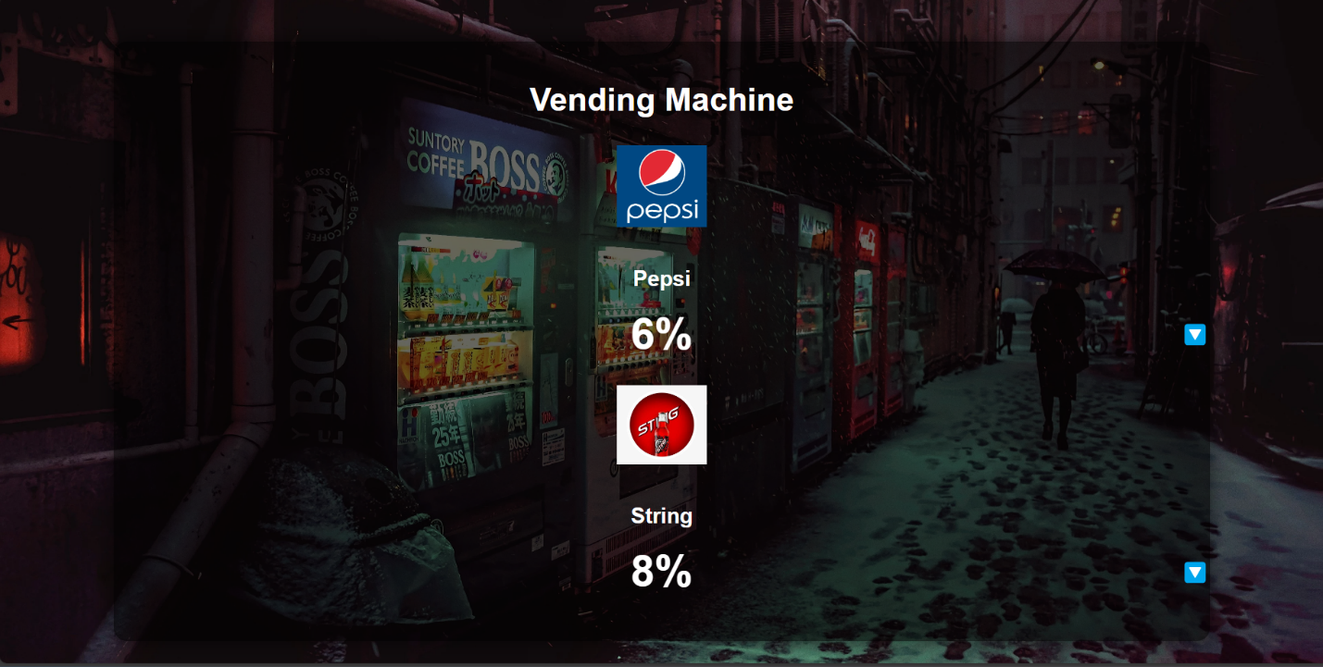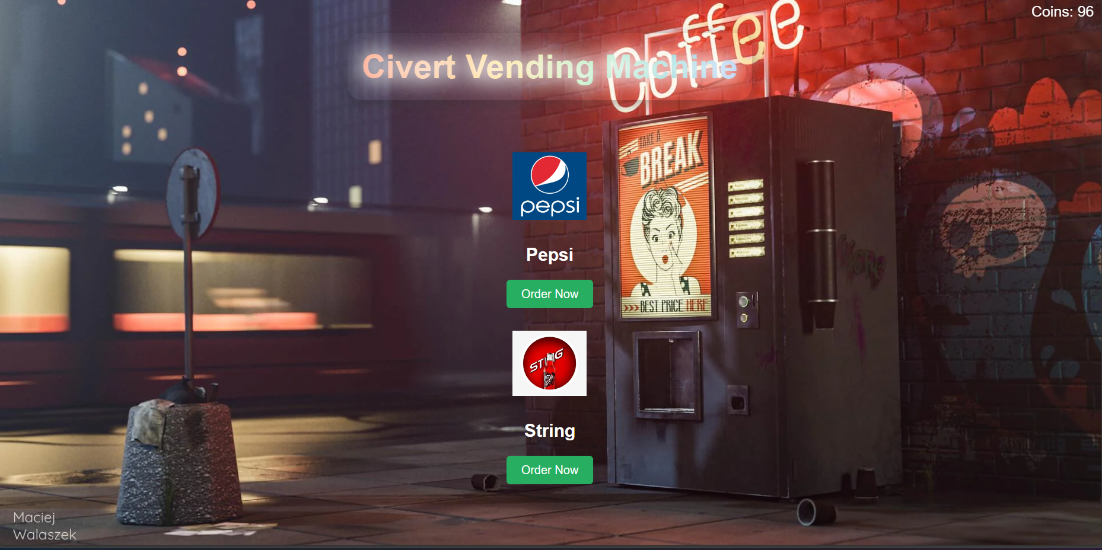

Figure 1admin interface

Figure 2user interface

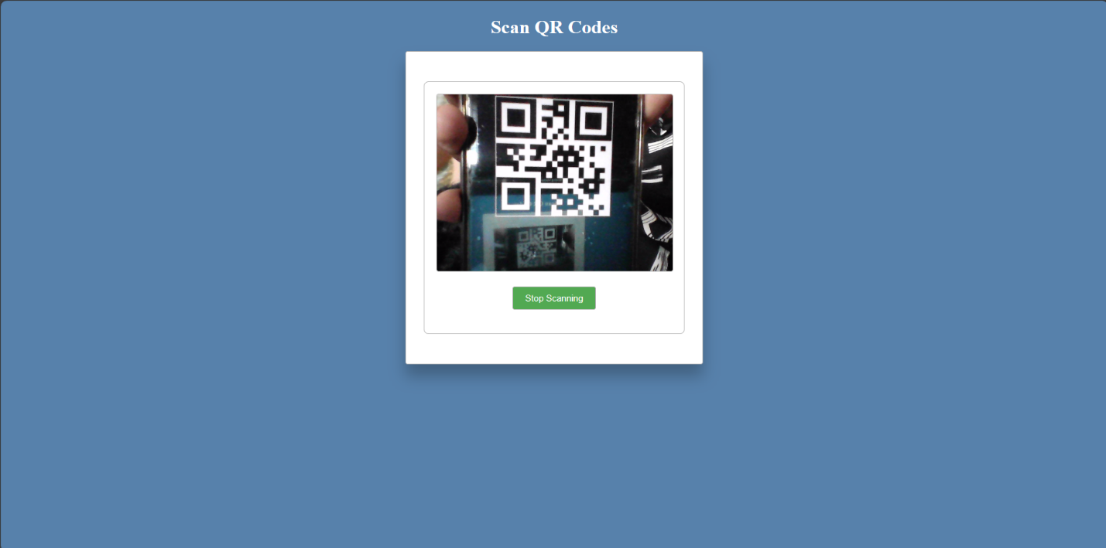

Figure 3scan QR code

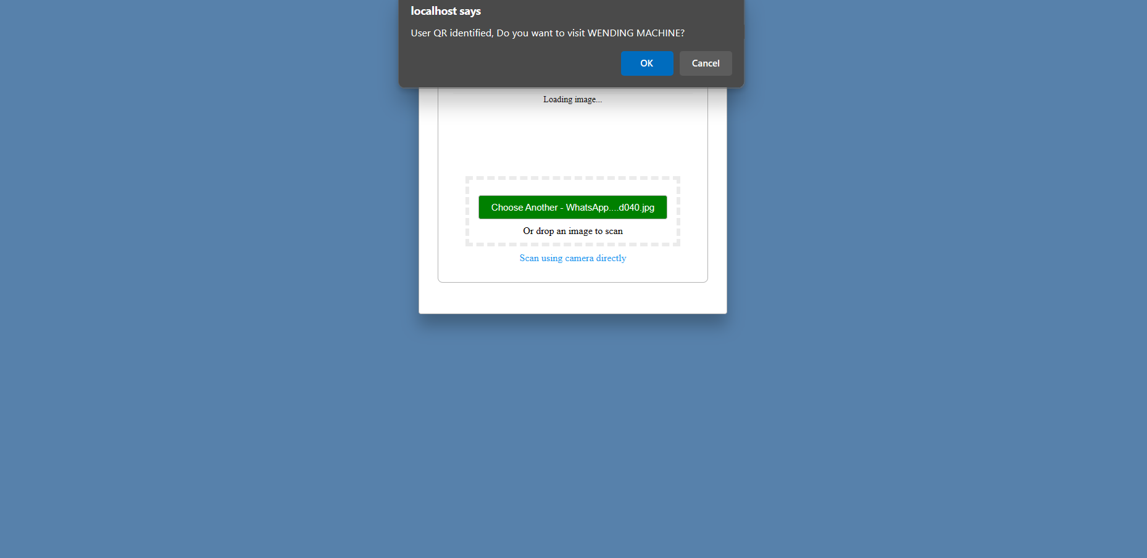

Figure 4scan QR code

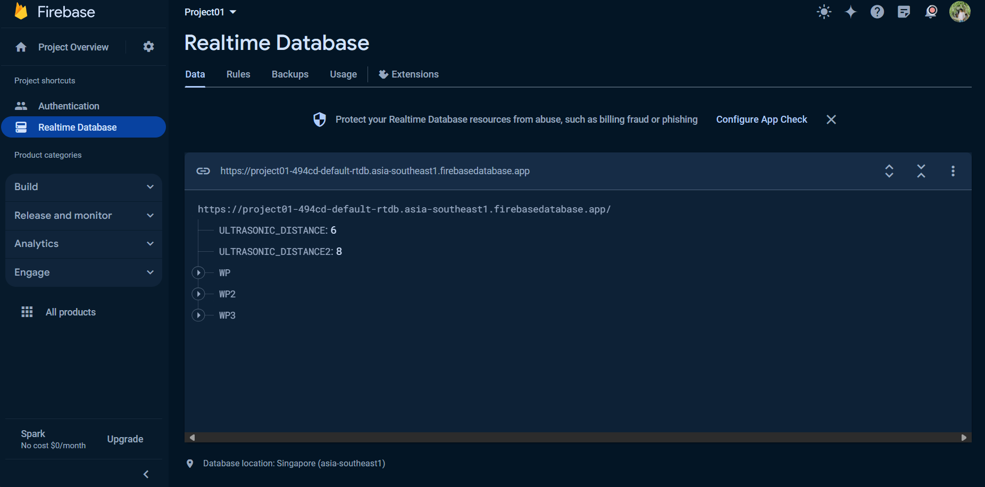

Figure 5realtime database